HELP I’M STUCK!

This guide will help you to find support with your work while school is closed. To have the words read to you, click the sound file and listen.

Double click here!



What do you want help with?

Reading the work sent to me

Writing/Typing my work at home

Learning to read

Spelling

Maths

Organisation

Focus & concentration

Boredom!

Worries

# 



Come join us in Student Support online just like it normally is when school is open.

|  |  |  |  |  |  |
| --- | --- | --- | --- | --- | --- |
| **Day** | **Monday** | **Tuesday** | **Wednesday** | **Thursday** | **Friday** |
| **Morning**  **(9.30 – 11.00)** | Ms Perkins and Mrs Mzmara | Mrs Vickers & Mr Grubb | Mr Birch & Mrs Aizlewood | Ms Perkins and Mrs Aizlewood | Mr Grubb & Mrs Mzmara |
| **Afternoon**  **(1.30-3.00)** | Mr Grubb & Mr Birch | Mrs Aizlewood & Ms Perkins | Mrs Vickers & Mrs Mzmara | Mr Grubb & Mrs Vickers | Mr Birch & Ms Perkins |

To access this room, **log into your school account on Google** and head to <https://chat.google.com/> where you can then search for the room Student Support.

The Google Chat app can also be downloaded on iPhone and Andriod in your appstores.

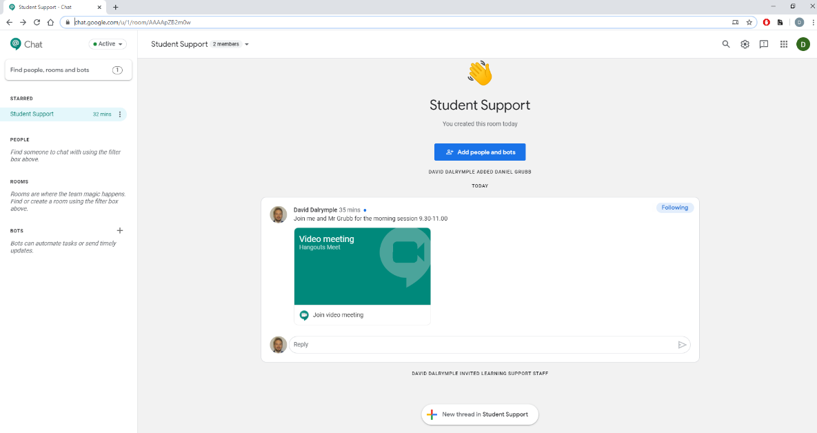You can also head straight to <https://chat.google.com/u/1/room/AAAApZB2m0w>

Check the room regularly as the team will schedule quizzes, games and activities just as they would during break time and lunch time while is school open.

You could log on…

* just to say hello to a familiar face
* to ask a quick question about a topic
* to ask for help with a piece of work you are finding difficult
* to ask for advice about how to organise the work
* to ask for help with how to structure your day
* Regularly while you work just in case you need help

We will always make sure that 2 members of staff will be on a video call with you to keep you and them safe.

If you aren’t comfortable with this you can email [learningsupport@silverdale-chorustrust.org](mailto:learningsupport@silverdale-chorustrust.org) and we can arrange to help you in another way.

# 

We now have a subscription to an app called Read & Write which you can install on a phone or laptop. It has the following features to help you:

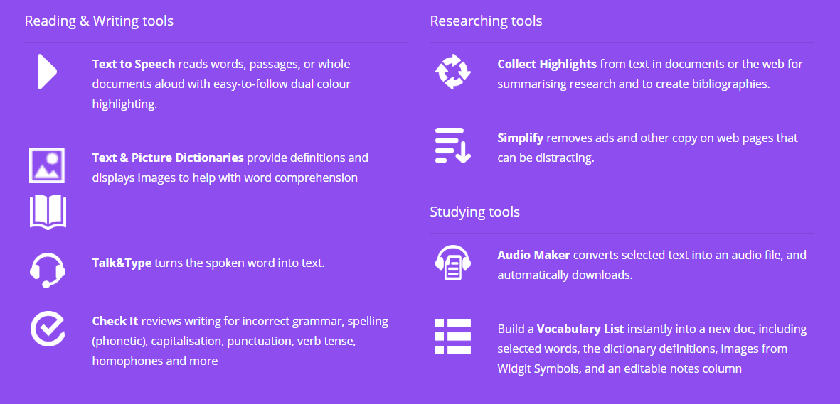

The app is free and can be downloaded here: [www.texthelp.com/en-gb/products/read-write/read-write-for-education/](http://www.texthelp.com/en-gb/products/read-write/read-write-for-education/) Click on “**try Read and Write”** and then select your device.

You can then log on using your school email address and password. If you don’t know your password, you need to email [itsupport@silverdale-chorustrust.org](mailto:itsupport@silverdale-chorustrust.org)

Here are some useful links which you can use to install and use the software.

* [Students](http://text.help/RLstudents)
* [Parents](http://text.help/RLparents)
* [Teachers](http://text.help/RLteachers)

# 



IDL Literacy is a program to help improve your reading and spelling. IDL can be accessed on Google Chrome or downloaded on phones and tablets.

If you would like to use IDL email Mr Grubb [dgrubb@silverdale-chorustrust.org](mailto:dgrubb@silverdale-chorustrust.org) and an account will be created for you.

To use IDL on the computer use this link: <https://appuk.idlsgroup.com/#/login>

To download IDL go to the Apple Store or the Play Store.

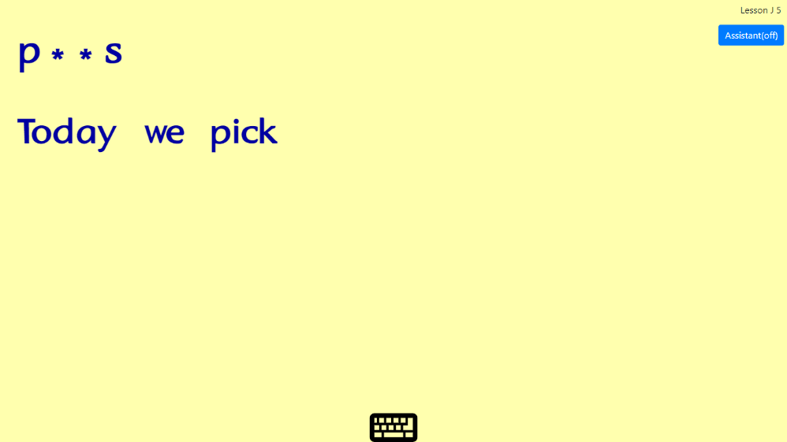

# 



IDL Numeracy is a program to support the maths learning of students who struggle to keep up with the content of their lessons. IDL can be accessed on Google Chrome or downloaded on phones and tablets.

If you would like to use IDL email Mr Grubb: [dgrubb@silverdale-chorustrust.org](mailto:dgrubb@silverdale-chorustrust.org) and an account will be created for you.

To use IDL on the computer use this link: <https://appuk.idlsgroup.com/#/login>

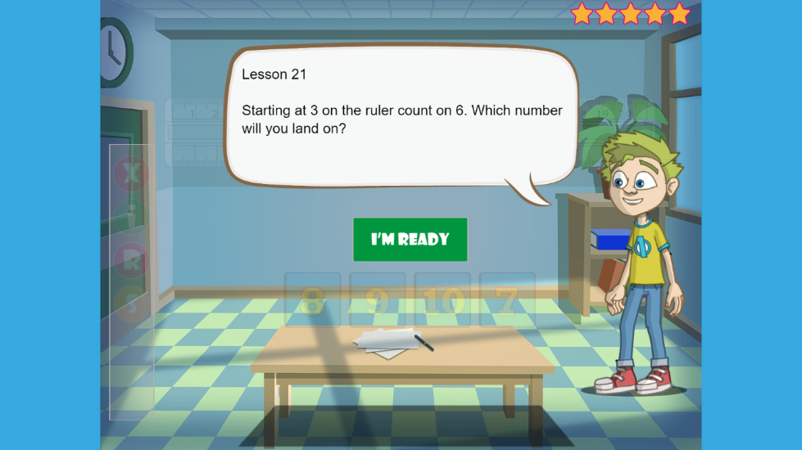To download IDL go to the Apple Store or the Play Store and search IDL Numeracy.

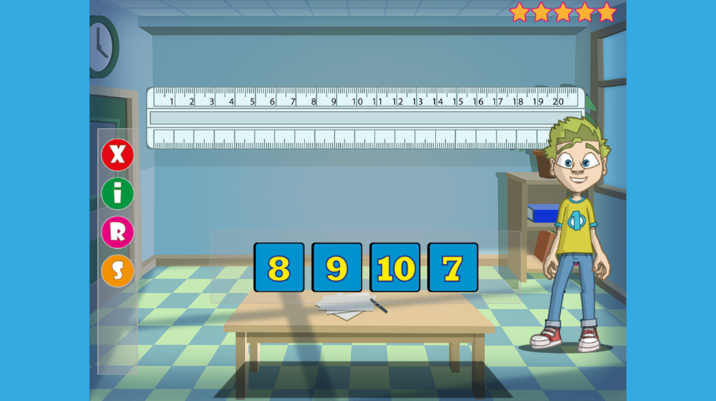

# 



Hello All,

Just to let you know that I will be running Art for Wellbeing sessions that will be informal, sometimes with a theme and sometimes led by the students on what they wish to create, encouraging individuality.

Activities will be varied, giving us opportunities to model make, draw, paint, play games and chat. We will sometimes work alongside our wonderful Silverdale Art Department, creating art based on weekly themes.

I aim to run the sessions every week that require just a small amount of materials so that it remains inclusive. We will be producing art that individually express how we feel and at times we will share this work with our peers in the group if the student wishes which can be helpful and freeing.

I am looking forward to the sessions being fun and creative in our new 'virtual classroom' environment where we can relax, spend time with friends and feel cared for.

I believe it should be about storytelling, helping people to develop a narrative and relate to their own experience in a new way.

Everyone is welcome and If you like the idea of being part of these sessions or you know someone who would like to join too, I would love to hear from you.

Please e-mail: [KAizlewood-Lubas@silverdale-chorustrust.org](mailto:KAizlewood-Lubas@silverdale-chorustrust.org)

Kindest Regards,

Mrs Aizlewood