  
A guide for parents of children with SEND

(Special Educational Needs & Disabilities)

At Silverdale, we understand that the closure of school will bring additional challenges to children with special educational needs and we anticipate that they will be worried about falling behind their peers if they are struggling to access the work. We also appreciate that the disruption to routine that COVID-19 has brought about may also have a negative impact on this group of children.

As such, we have put together a guide to allow you to find support for your child in the ways that they need it. We have always found that clear communication is key so please get in touch via email if you have any questions or suggestions: [ddalrymple@silverdale-chorustrust.org](mailto:ddalrymple@silverdale-chorustrust.org)

**Help! My child is struggling with…**

Reading the work sent to them

Writing/Typing their work at home

Learning to read

Spelling

Maths

Organisation

Focus & concentration

Boredom!

Worries

In the rest of this document you will find information about how we can help your child with their learning.

* Student Support Online
* Read & Write
* IDL Literacy
* IDL Numeracy
* Art for Wellbeing

# 

We understand many parents are faced with a new challenge in supervising their children’s learning while attempting to complete their own work from home. This may be a particularly challenging time for parents of SEND children. As such, we encourage you to use us to help your child just as we would if the school building were open. During normal school time, students access Student Support and receive help for their work. In Student Support, they can also find a safe place to socialise with friendly peers and adults.

We want to give students the chance to see familiar faces and receive similar help and support to when the school is open. As such, we are running a ‘Virtual Student Support’. For 90 minutes in the morning and 90 minutes in the afternoon, two members of staff will be logged onto our virtual classroom available for voice, typed or video chat.

|  |  |  |  |  |  |
| --- | --- | --- | --- | --- | --- |
| **Day** | **Monday** | **Tuesday** | **Wednesday** | **Thursday** | **Friday** |
| **Morning**  **(9.30 – 11.00)** | Ms Perkins and Mrs Mzmara | Mrs Vickers & Mr Grubb | Mr Birch & Mrs Aizlewood | Ms Perkins and Mrs Aizlewood | Mr Grubb & Mrs Mzmara |
| **Afternoon**  **(1.30-3.00)** | Mr Grubb & Mr Birch | Mrs Aizlewood & Ms Perkins | Mrs Vickers & Mrs Mzmara | Mr Grubb & Mrs Vickers | Mr Birch & Ms Perkins |

To access this room, your child needs **to log into their school account on Google** and head to <https://chat.google.com/> where they can then search for the room Student Support.

The Google Chat app can also be downloaded on iPhone and Andriod in their appstores.

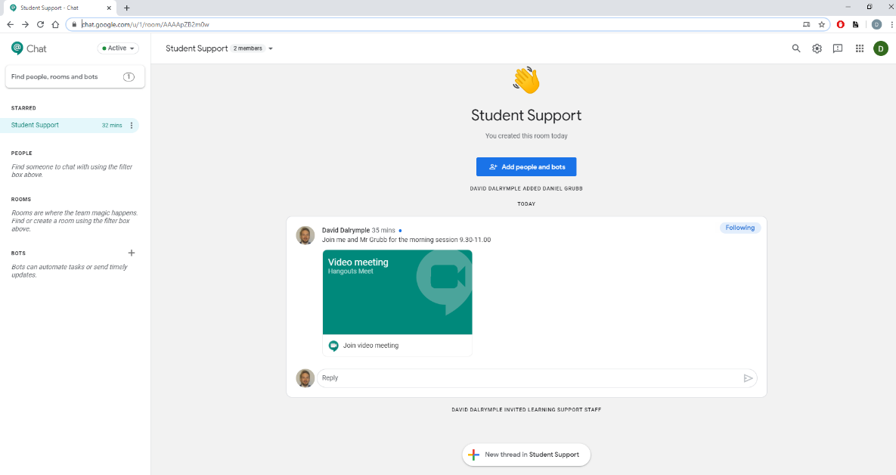Alternatively, they can head straight to <https://chat.google.com/u/1/room/AAAApZB2m0w>

Check the room regularly as the team will schedule quizzes, games and activities just as they would during break time and lunch time while is school open.

Your child could log on…

* just to say hello to a familiar face
* to ask a quick question about a topic
* to ask for help with a piece of work they are finding difficult
* to ask for advice about how to organise the work
* to ask for help with how to structure their day
* Regularly while they work just in case they need help

The room will allow your child to upload their work for us to check or help them with as well as join us in video calls if they want to talk face to face. We will always ensure that 2 members of staff will be on a video call with students.

If your child isn’t comfortable with this arrangement, they can email [learningsupport@silverdale-chorustrust.org](mailto:learningsupport@silverdale-chorustrust.org) and we can arrange to help them in another way.

# 

We now have a subscription to an app called Read & Write which you can install on a phone or laptop. It has the following features to help your child:

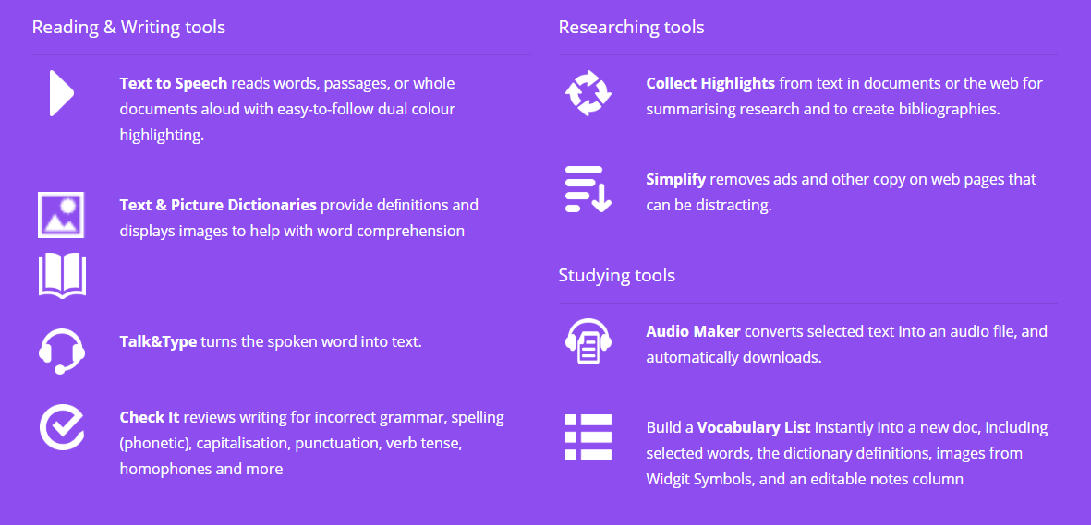

The app is free and can be downloaded here: [www.texthelp.com/en-gb/products/read-write/read-write-for-education/](http://www.texthelp.com/en-gb/products/read-write/read-write-for-education/) Click on “**try Read and Write”** and then select your device.

Your child can then log on using their school email address and password. If they don’t know their password, they need to email [itsupport@silverdale-chorustrust.org](mailto:itsupport@silverdale-chorustrust.org)

Here are some useful links which you and your child can use to install and use the software.

* [Students](http://text.help/RLstudents)
* [Parents](http://text.help/RLparents)
* [Teachers](http://text.help/RLteachers)

# 

IDL Literacy is a program we use to support children who struggle with their reading and spelling. IDL can be accessed on Google Chrome or downloaded on phones and tablets.

If you would like your child to use IDL email [dgrubb@silverdale-chorustrust.org](mailto:dgrubb@silverdale-chorustrust.org) and an account will be created for them.

To use IDL on the computer use this link: <https://appuk.idlsgroup.com/#/login>

To download IDL go to the Apple Store or the Play Store.

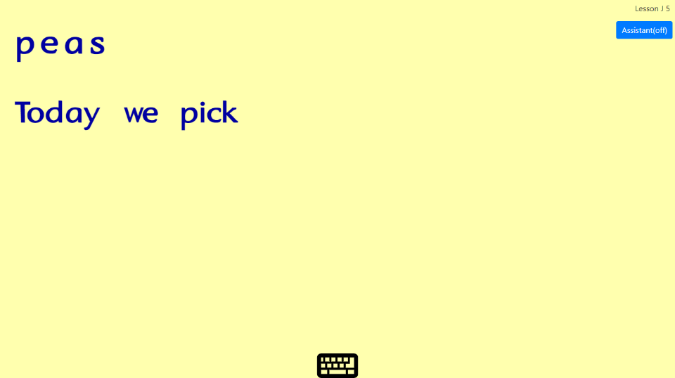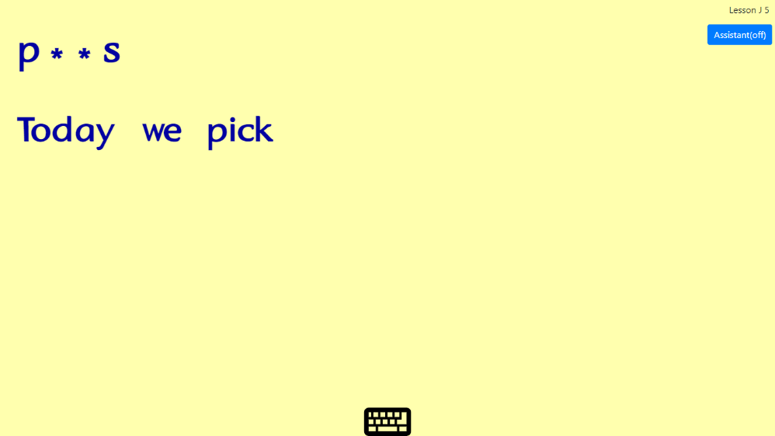

# 

IDL Numeracy is a program we use in school to support the maths learning of students who struggle to keep up with the content of their lessons. IDL can be accessed on Google Chrome or downloaded on phones and tablets.

If you would like your child to use IDL email [dgrubb@silverdale-chorustrust.org](mailto:dgrubb@silverdale-chorustrust.org) and an account will be created for them.

To use IDL on the computer use this link: <https://appuk.idlsgroup.com/#/login>

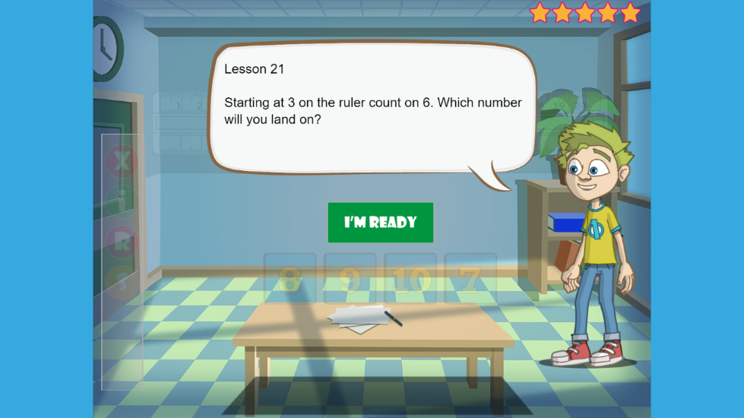To download IDL go to the Apple Store or the Play Store and search IDL Numeracy.

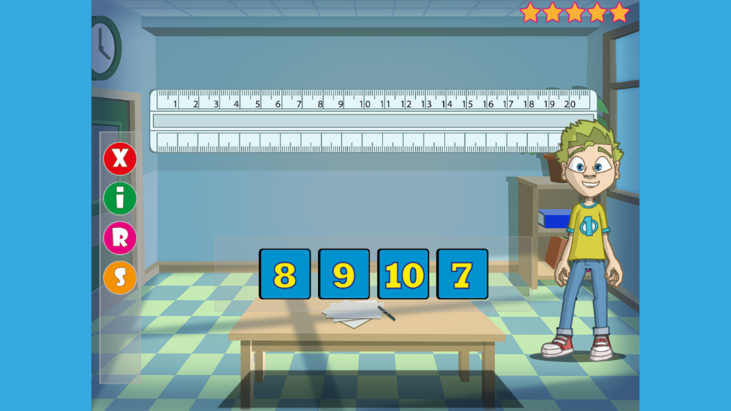

# 

Hello All,

Just to let you know that I will be running Art for Wellbeing sessions that will be informal, sometimes with a theme and sometimes led by the students on what they wish to create, encouraging individuality.

Activities will be varied, giving us opportunities to model make, draw, paint, play games and chat. We will sometimes work alongside our wonderful Silverdale Art Department, creating art based on weekly themes.

I aim to run the sessions every week that require just a small amount of materials so that it remains inclusive. We will be producing art that individually express how we feel and at times we will share this work with our peers in the group if the student wishes which can be helpful and freeing.

I am looking forward to the sessions being fun and creative in our new 'virtual classroom' environment where we can relax, spend time with friends and feel cared for.

I believe it should be about storytelling, helping people to develop a narrative and relate to their own experience in a new way.

Everyone is welcome and If you like the idea of being part of these sessions or you know someone who would like to join too, I would love to hear from you.

Please e-mail: [KAizlewood-Lubas@silverdale-chorustrust.org](mailto:KAizlewood-Lubas@silverdale-chorustrust.org)

Kindest Regards,

Mrs Aizlewood